**Módulo 4 – Atividade**

Link repositório GitHub:

Link do YAML:

Print de telas:

Telals:

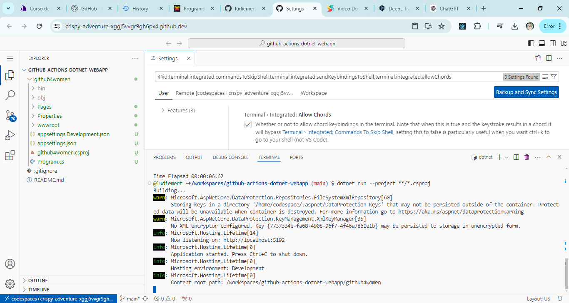

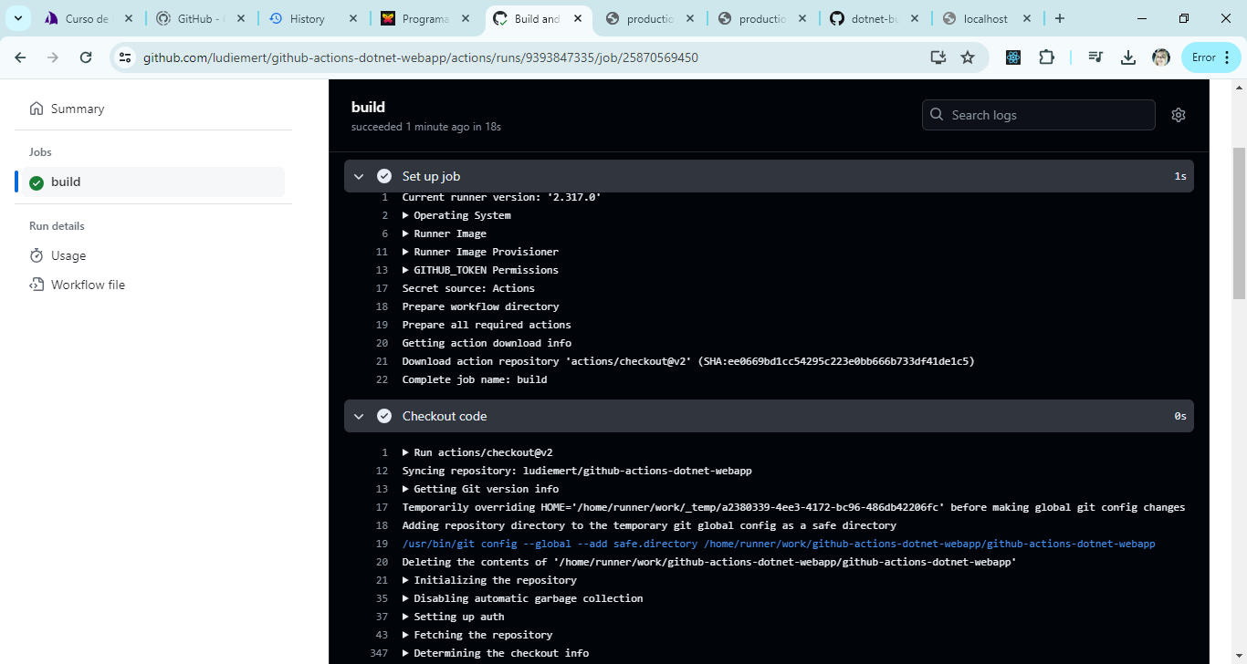

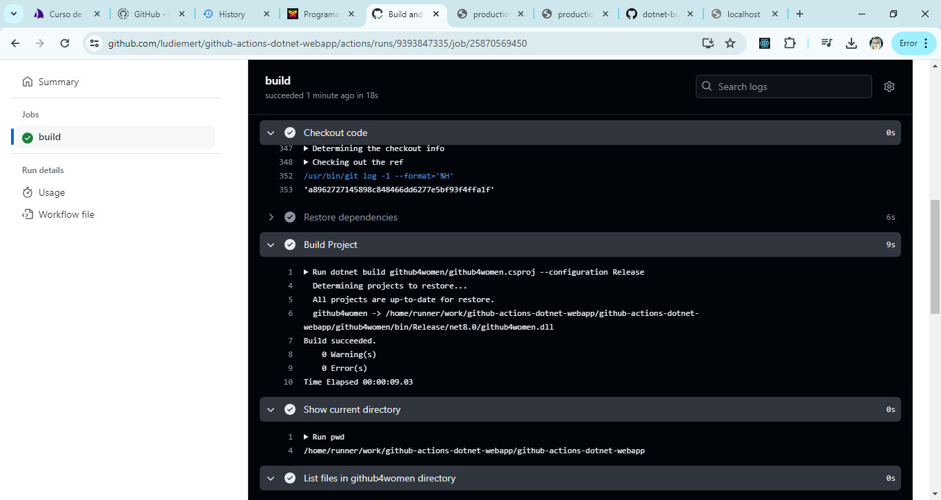

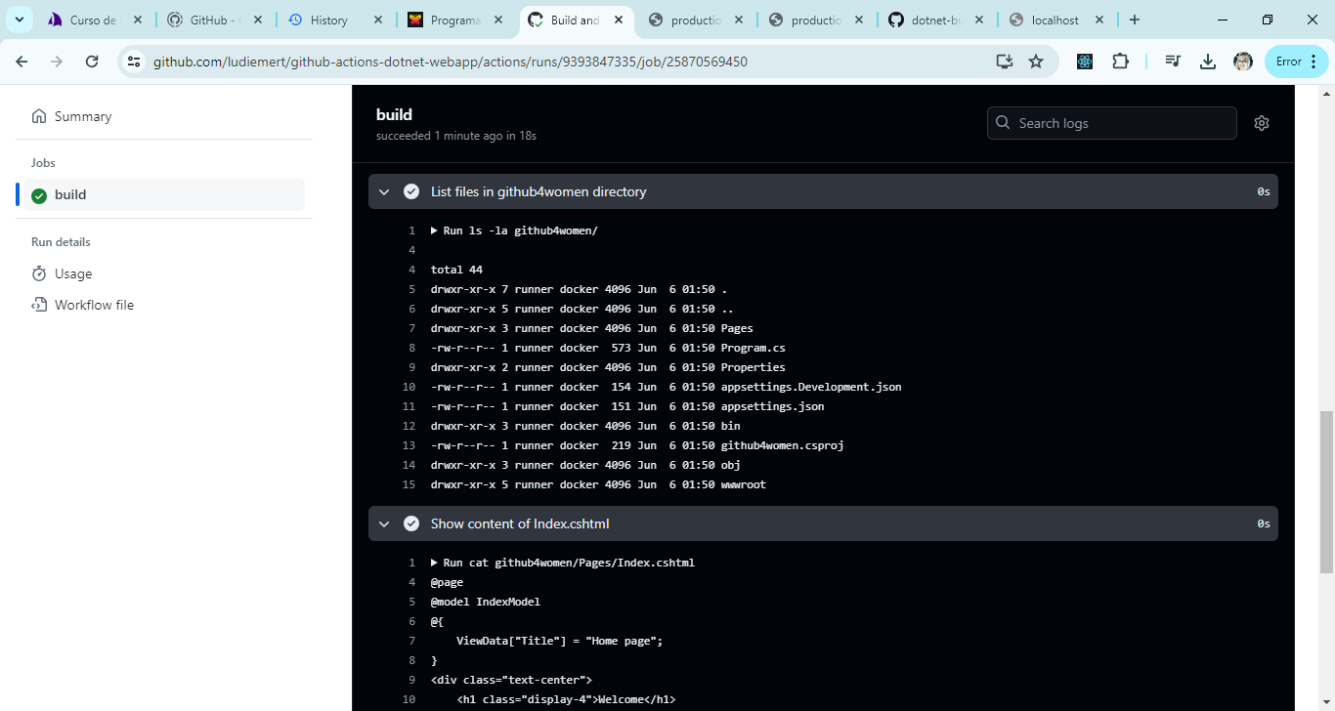

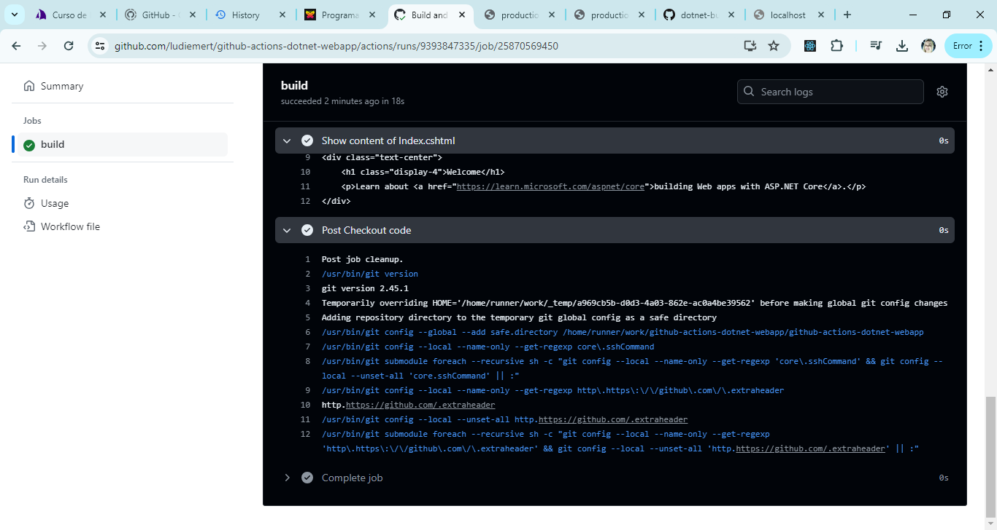

<https://github.com/ludiemert/github-actions-dotnet-webapp.git>

link actions: <https://github.com/ludiemert/github-actions-dotnet-webapp>

Arquivo YAML:

Este arquivo .yaml irá executar os seguintes passos:

1. Fazer o checkout do código.
2. Restaurar as dependências do projeto.
3. Construir o projeto.
4. Exibir o diretório atual.
5. Listar os arquivos no diretório github4women.
6. Exibir o conteúdo do arquivo Index.cshtml.

name: Build and Schedule Workflow

on:

push:

branches:

- main

schedule:

- cron: "0 * * * *"

jobs:

build:

runs-on: ubuntu-latest

steps:

- name: Checkout code

uses: actions/checkout@v2

- name: Restore dependencies

run: dotnet restore github4women/github4women.csproj

- name: Build Project

run: dotnet build github4women/github4women.csproj --configuration Release

- name: Show current directory

run: pwd

- name: List files in github4women directory

run: ls -la github4women/

- name: Show content of Index.cshtml

run: cat github4women/Pages/Index.cshtml